🌍 YAAR-YATRA – Travel Companion
YAAR-YATRA is a modern travel companion web application designed to help users plan, explore, and manage their trips effortlessly. The platform provides an intuitive interface for discovering destinations, organizing itineraries, and enhancing the overall travel experience.

🚀 Features
* 🗺️ **Explore Destinations** – Discover popular and hidden travel spots
* 📅 **Trip Planning** – Create and manage travel itineraries
* 👥 **User-Friendly Interface** – Smooth navigation and responsive design
* 📊 **Travel Insights** – View trip details and personalized suggestions
* 🔐 **Authentication System** – Secure user login and registration

🛠️ Tech Stack
Frontend
* React.js
* HTML5, CSS3, JavaScript

Backend
* Node.js
* Express.js

Database
* MySQL

📂 Project Structure
YAAR-YATRA/
│── client/ # Frontend (React)
│── server/ # Backend (Node + Express)
│── database/ # Database scripts
│── assets/ # Images and static files
│── README.md

⚙️ Installation & Setup
1️⃣ Clone the repository
bash
git clone https://github.com/SUSHANTHPVS/YAAR-YATRA.git
cd YAAR-YATRA

2️⃣ Install dependencies
For frontend
```bash
cd client
npm install
npm start
```
#### For backend
```bash
cd server
npm install
npm start

## 🔧 Environment Variables
Create a `.env` file in the server folder and add:
```
DB_HOST=your_host
DB_USER=your_user
DB_PASSWORD=your_password
DB_NAME=your_database
PORT=5000
```
📸 Screenshots
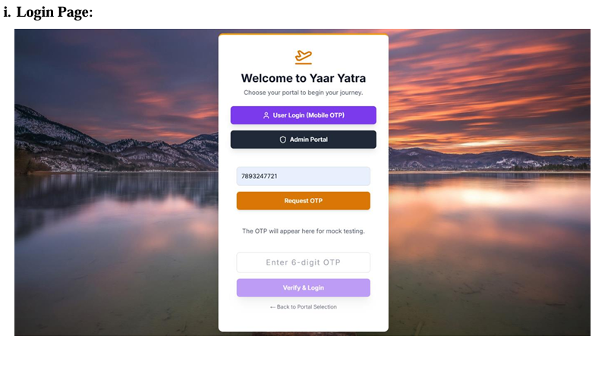
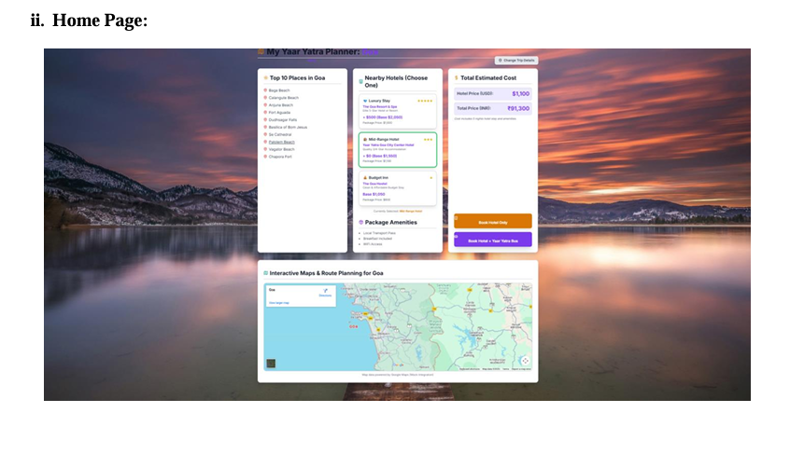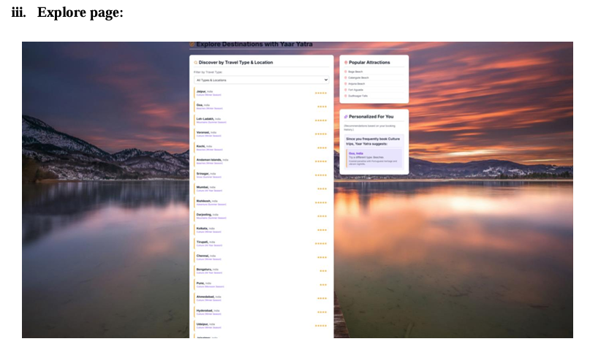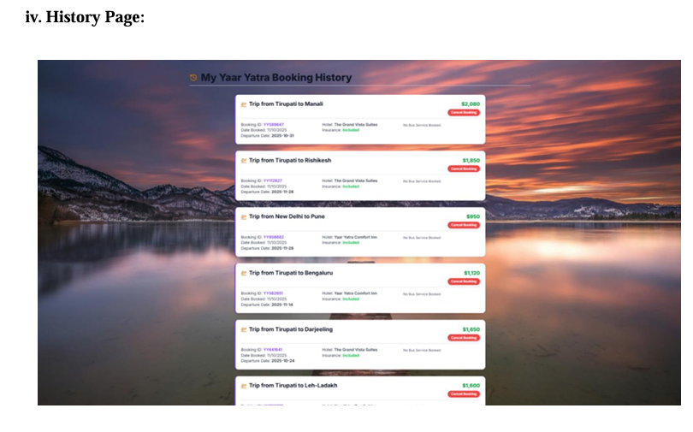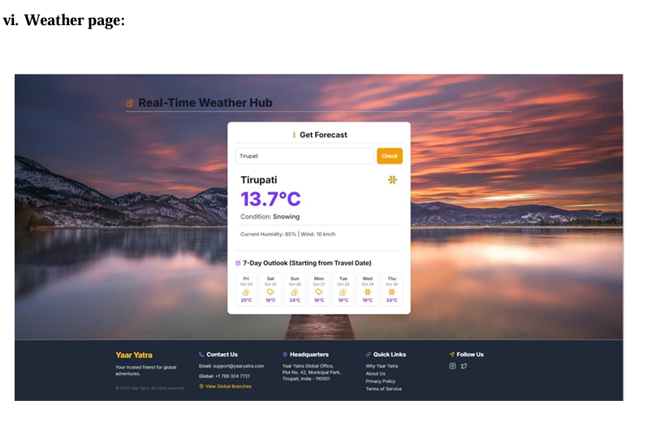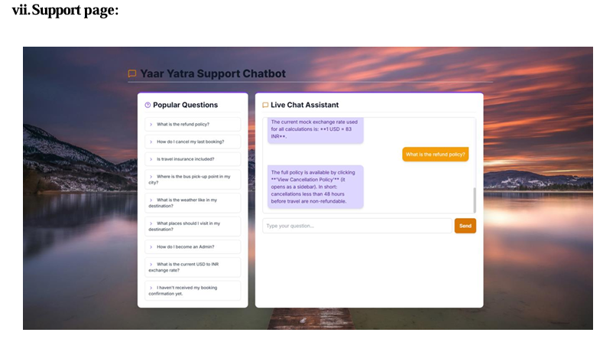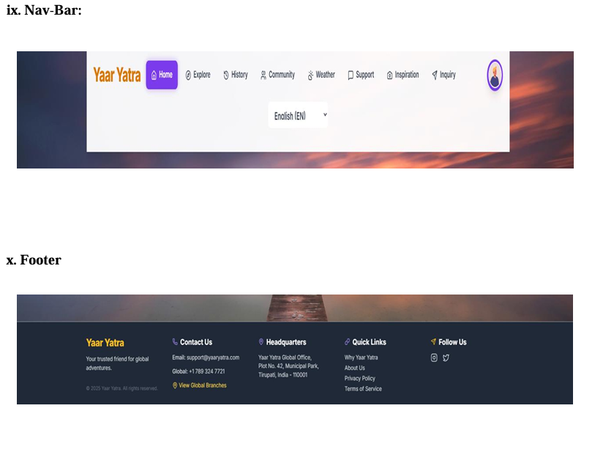

📌 Future Enhancements
* 🌐 Real-time travel recommendations
* 📍 GPS-based location tracking
* 💳 Online booking integration
* 🤖 AI-based travel suggestions
🤝 Contributing
Contributions are welcome!
Feel free to fork the repo and submit a pull request.
👨‍💻 Author
Sushanth P V S

* GitHub: https://github.com/SUSHANTHPVS

